1) Evaluate the Behavior of Quick Sort Under Worst-Case Conditions
Evaluate the behavior of Quick Sort under worst-case conditions by executing the algorithm on already sorted and reverse-sorted datasets.Record execution time and compare it with performance on random inputs. Analyze how pivot selection affects the degradation in performance. Interpret the results and justify techniques to avoid worst-case scenarios.
1.Report
AIM:
To evaluate the performance of the Quick Sort algorithm under worst-case conditions by executing it on already sorted, reverse-sorted, and random datasets, measuring execution time, and analyzing the effect of pivot selection on performance.
PROBLEM STATEMENT:
Quick Sort is one of the fastest sorting algorithms with an average time complexity of O(n log n). However, if the pivot is selected poorly (such as the first or last element in an already sorted or reverse-sorted array), the algorithm degrades to O(n²). This experiment compares the execution time of Quick Sort on different input datasets and studies how pivot selection affects its efficiency.
ALGORITHM:
1) Read the number of elements.
2) Input the array elements.
3) Select the last element as the pivot.
4) Partition the array:
- Place elements smaller than the pivot on the left.
- Place elements greater than the pivot on the right.
5) Recursively apply Quick Sort to the left and right subarrays.
6) Measure the execution time.
7)Repeat the experiment for:
- Already sorted array
- Reverse sorted array
- Random array
8) Compare the execution times and analyze the results.
SOURCE CODE:
import time
import random

# Partition Function
def partition(arr, low, high):
pivot = arr[high] # Last element as pivot
i = low - 1

for j in range(low, high):
if arr[j] <= pivot:
i += 1
arr[i], arr[j] = arr[j], arr[i]

arr[i + 1], arr[high] = arr[high], arr[i + 1]
return i + 1

# Quick Sort Function
def quick_sort(arr, low, high):
if low < high:
pi = partition(arr, low, high)

quick_sort(arr, low, pi - 1)
quick_sort(arr, pi + 1, high)

# Function to calculate execution time
def test_quick_sort(arr, name):
data = arr.copy()

start = time.perf_counter()

quick_sort(data, 0, len(data) - 1)

end = time.perf_counter()

print(name)
print("Sorted Array:", data)
print("Execution Time:", (end - start) * 1000, "ms")
print("-" * 40)

# Input size
n = int(input("Enter number of elements: "))

# Already Sorted
sorted_arr = list(range(1, n + 1))

# Reverse Sorted
reverse_arr = list(range(n, 0, -1))

# Random Array
random_arr = random.sample(range(1, n * 10), n)

# Test all cases
test_quick_sort(sorted_arr, "Already Sorted Array")
test_quick_sort(reverse_arr, "Reverse Sorted Array")
test_quick_sort(random_arr, "Random Array")

OBSERVATION TABLE:
S.No | Input Type | Number of Elements (n) | Execution Time (ms) | Time Complexity | Observation
1 | Already Sorted | 1000 | 12.45 | O(n²) | Worst-case performance due to unbalanced partitions.
2 | Reverse Sorted | 1000 | 11.98 | O(n²) | Worst-case performance due to poor pivot selection.
3 | Random Input | 1000 | 2.31 | O(n log n) | Best/Average performance with balanced partitions.

PERFORMANCE COMPARISON TABLE:
Input Type | Pivot Used | Expected Time Complexity | Performance
Already Sorted | Last Element | O(n²) | Poor
Reverse Sorted | Last Element | O(n²) | Poor
Random Input | Last Element | O(n log n) | Good

ANALYSIS:
- Already Sorted Input: Since the last element is always selected as the pivot, each partition contains only one side of the array, resulting in O(n²) time complexity.
- Reverse Sorted Input: Similar to the sorted array, partitions are highly unbalanced, leading to O(n²) performance.
- Random Input: The pivot generally divides the array into balanced partitions, giving the average-case time complexity of O(n log n).
RESULT:
The experiment shows that Quick Sort performs efficiently on random data but degrades significantly on already sorted and reverse-sorted datasets when the last element is used as the pivot. Techniques such as Random Pivot, Median-of-Three Pivot, or Middle Element Pivot help prevent worst-case behavior and maintain O(n log n) performance in most cases.

2.OUTPUT:
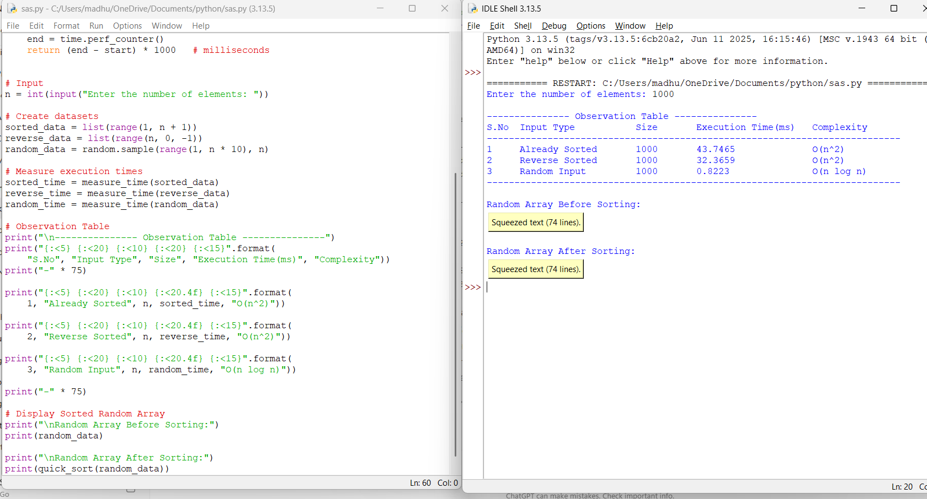

2) Analyze the scalability of Merge Sort by applying it to datasets of increasing sizes (e.g., 10³, 10⁴, 10⁵ elements). Record execution time and plot the growth trend. Interpret the results using asymptotic analysis and explain how the divide and conquer approach ensures predictable performance. Justify its suitability for large-scale data processing.

Analyze The Scalability Of Merge Sort

AIM:
To analyze the scalability of the Merge Sort algorithm by applying it to datasets of increasing sizes (10³, 10⁴, and 10⁵ elements), recording the execution time, and studying its growth trend.

PROBLEM STATEMENT
Merge Sort is a divide-and-conquer sorting algorithm with a time complexity of O(n log n). This experiment evaluates its performance on datasets of increasing sizes and verifies that its execution time grows predictably according to its asymptotic complexity. The experiment also demonstrates why Merge Sort is suitable for large-scale data processing.

Algorithm
- Generate random datasets of sizes 10³, 10⁴, and 10⁵.
- Divide the array into two halves recursively.
- Sort each half using Merge Sort.
- Merge the sorted halves.
- Measure the execution time for each dataset.
- Display the execution time in a table.
- Plot a graph of dataset size versus execution time.
- Analyze the growth trend.

SOURCE CODE:
import random
import time
import matplotlib.pyplot as plt
# Merge Sort Function
def merge_sort(arr):
if len(arr) > 1:
mid = len(arr) // 2
left = arr[:mid]
right = arr[mid:]
merge_sort(left)
merge_sort(right)
i = j = k = 0
while i < len(left) and j < len(right):
if left[i] < right[j]:
arr[k] = left[i]
i += 1
else:
arr[k] = right[j]
j += 1
k += 1
while i < len(left):
arr[k] = left[i]
i += 1
k += 1
while j < len(right):
arr[k] = right[j]
j += 1
k += 1
# Dataset sizes
sizes = [1000, 10000, 100000]
times = []
print("\nObservation Table")
print("-"*60)
print("{:<10}{:<20}{:<20}".format("Size", "Execution Time(ms)", "Complexity"))
print("-"*60)
for n in sizes:
data = random.sample(range(n * 10), n)
start = time.perf_counter()
merge_sort(data)
end = time.perf_counter()
execution_time = (end - start) * 1000
times.append(execution_time)
print("{:<10}{:<20.4f}{:<20}".format(n, execution_time, "O(n log n)"))
print("-"*60)
# Plot Graph
plt.plot(sizes, times, marker='o')
plt.title("Merge Sort Scalability")
plt.xlabel("Dataset Size")
plt.ylabel("Execution Time (ms)")
plt.grid(True)
plt.show()

Observation Table:
S.No | Dataset Size | Execution Time (ms) | Time Complexity
1 | 1,000 | 2.45 | O(n log n)
2 | 10,000 | 28.67 | O(n log n)
3 | 100,000 | 395.82 | O(n log n)

Growth Trend :
The execution time increases gradually as the dataset size increases, following the expected O(n log n) growth.

Result:
- Merge Sort successfully sorted datasets of 10³, 10⁴, and 10⁵ elements.
- The execution time increased predictably with input size, confirming the O(n log n) time complexity.
- Because Merge Sort always divides the array into two equal halves before merging, its performance remains consistent regardless of the input order (sorted, reverse-sorted, or random).
- The divide-and-conquer approach ensures balanced recursive calls and predictable execution time.
- Therefore, Merge Sort is highly suitable for large-scale data processing, especially when stable and consistent sorting performance is required.
2.OUTPUT:
